Download the “RapidSMS” App | Scan the this QR code to download RapidSMS App
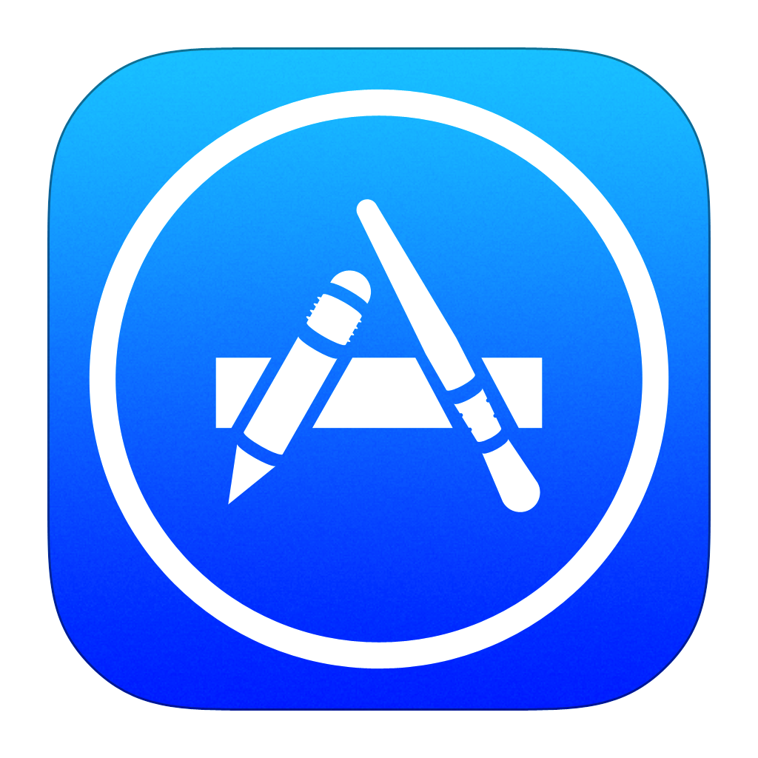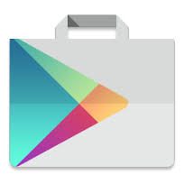  App Store Play Store | 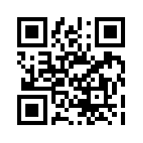
3 Steps to Register for RapidSMS APP

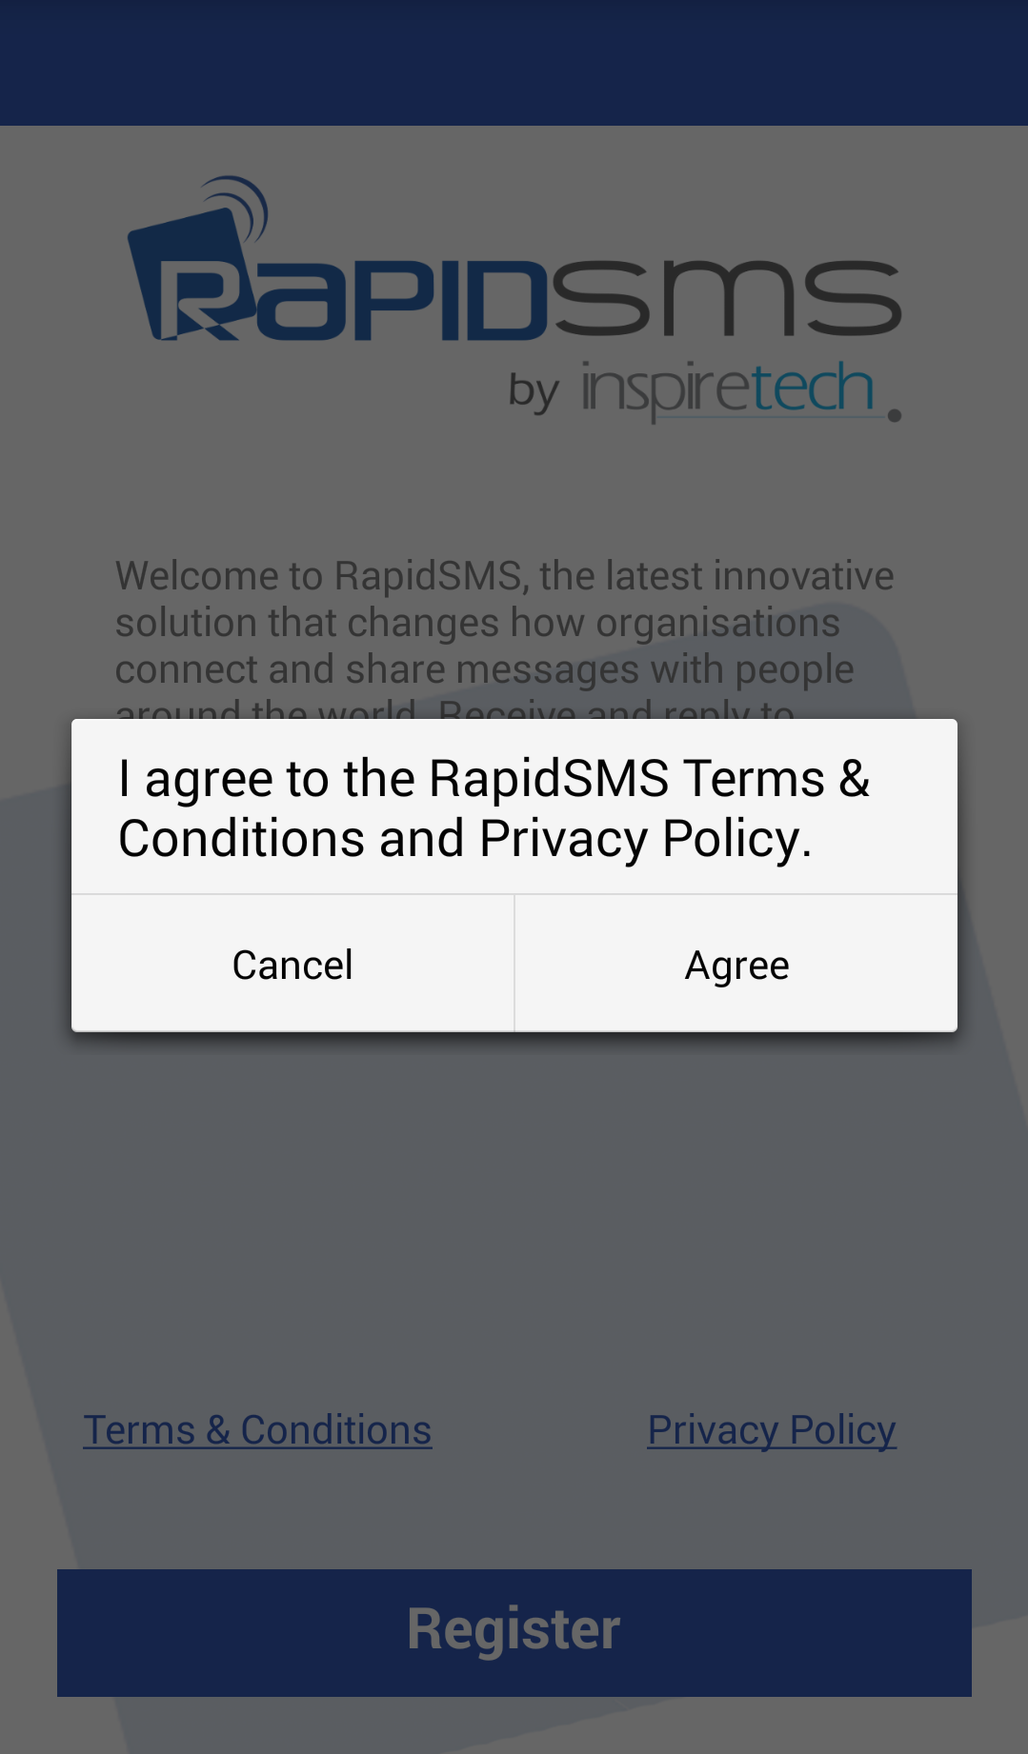 | Step 1: Download and launch App to Register  1.Tap Register  2. Tap Agree
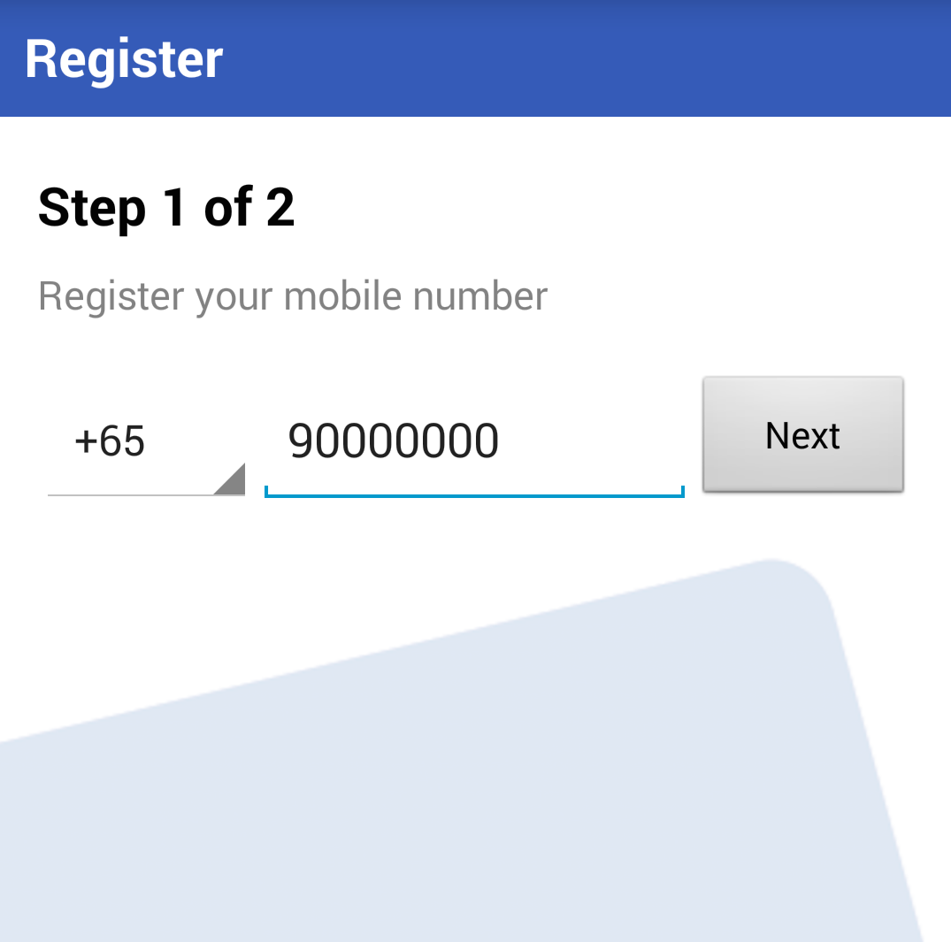 | Step 2: Enter your phone number  Enter your phone number in the above format.  An One-Time-Password (OTP) will be sent to your phone.
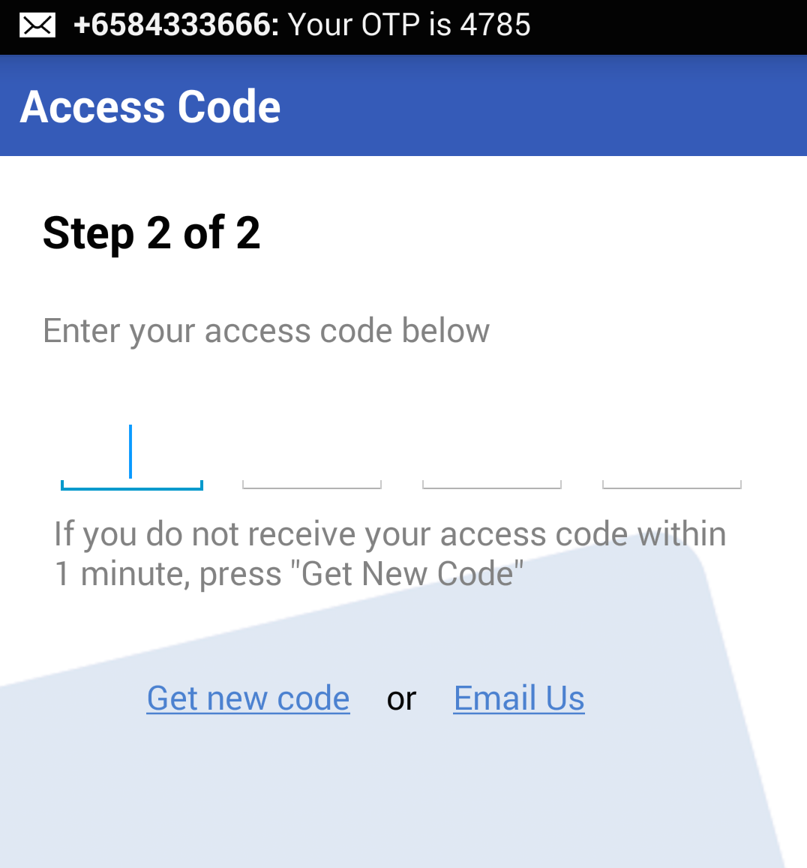 | Step 3: Enter your OTP and done!  You will receive a SMS with your 4-digit access code from RapidSMS. If you did not receive an SMS after 2 minutes, tap “Get new code”.  Note: Please ensure you stable LTE/GSM/WCDMA connection
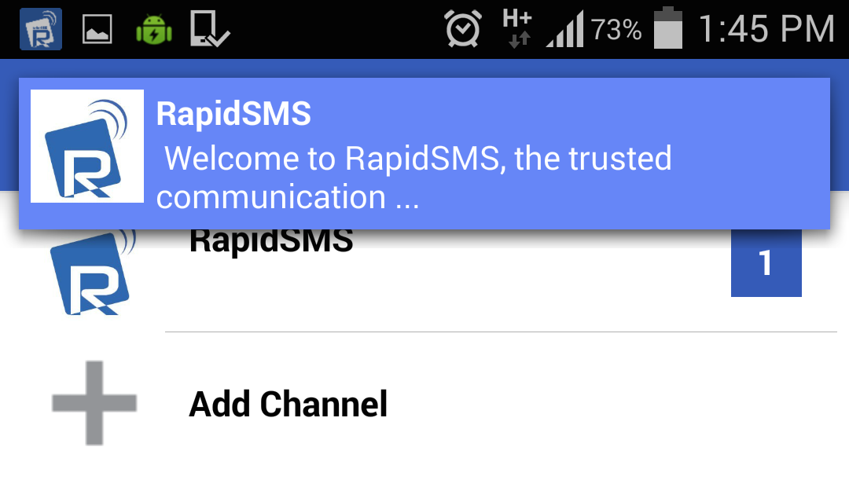 | Ensure you receive the 1st welcome message  Once you are done with registering, RapidSMS App will fetch your first Push Message.  You can tap on Push Message to view message directly.  Once the school has sent you a message, you will see the school’s name here.
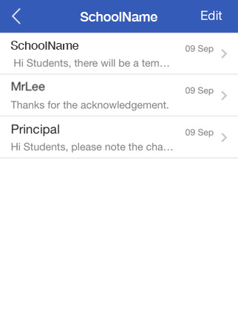 | View all department’s message  In the previous page, tap on the school’s name and you will be able to view all the message send you by different department.  Tap on the message from each department to the past conversations.

